1) Name of Seminar: Ozone Layer Depletion Awareness Program
2) Date of seminar: 16/09/2023
3) Time: 10 am to 12 pm
4) Name of Expert: Prof. Minarva J. Pandya

5) Name of Coordinator: Prof. Minarva J. Pandya
6) Designation of Coordinator: Associate Professor, Environmental Engineering Department,
L. D. College of Engineering

7) Email ID: minarva.pandya@ldce.ac.in
8) Mobile No: 9428362158
9) Number of Participants: 67
10) Registration Link:
- Environmental Students: https://forms.gle/yrdYMsb1ycf1D9JK9
- NSS: https://forms.gle/DLCeAHpAN6xwgXV6A
11) Expert contact No. : 9428362158
12) Expert email ID: minarva.pandya@ldce.ac.in
13) Expert’s Designation and college name: Associate Professor, Environmental Engineering
Department, L. D. College of Engineering
14) Photo graphs of Seminar:
As a part of world ozone day celebration, environmental engineering department has given awareness about ozone layer depletion and sustainable development to the environmental engineering first-year students. So that students as a responsible citizens can take the specific actions to protect the Earth’s Ozone layer.

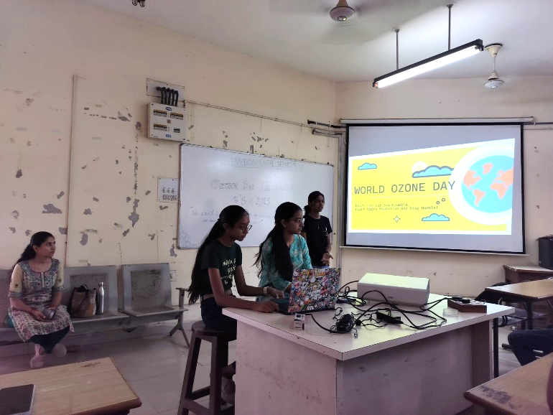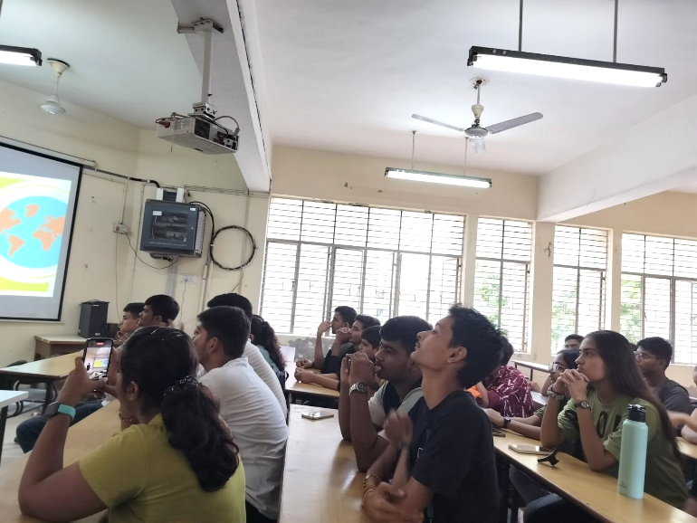
World Ozone Day awareness to students
15) Venue: L. D. College of Engineering

